  - Power of Our Thoughts & Words Unit

Unit Overview
Unit Focus:
- The focus of this unit is to understand the power of the words we use to tell our stories and the role they play in shaping our lives.

Unit Outcomes: By the end of the Unit learners will be able to:
- Realize that they are more than a single story
- Understand the power that words have to shape their experiences
- Develop strategies to experience things in a new way

Unit Weekly Themes:
- I Am More Than a Single Story
- My Thoughts & Words Have Power
- I Can Tell a New Story
- Finding My Voice

Affirmations
- I choose words that empower me and others.
- I am a diverse creation in God’s world.
- I allow my stories to change as I grow in wisdom.
- I use my voice as a tool of power, wisdom, and love.

Bible Quotes
- In the beginning was the Word, and the Word was with God, and the Word was God. John 1:1
- All power is given to me in heaven and in earth. Matthew 28:18
- Let the words of my mouth and the meditation of my heart be acceptable to you, O Lord, my rock and my redeemer. Psalm 19:14
- He woke up and rebuked the wind, and said to the sea, “Peace, be still!” Then the wind ceased and there was a dead calm. Matthew 4:39

Unity/Fillmore Quotes
- Christian Healing p65
Every time we speak we cause the atoms of the body to tremble and change their places. Not only do we cause the atoms of our own body to change their position, but we raise or lower the rate of vibration and otherwise affect the bodies of others with whom we come in contact.
- Jesus Christ Heals p112
Change your thought seeds and reap what you desire. Some bring forth very quickly, others more slowly, but all in divine order.
- Atom Smashing Power of Mind p75
Your mind, body, and affairs are the expression of your thoughts, so if you are not happy, change your mental habits.
- Dynamics for Living p262
If you are obedient to Spirit you will not suffer burdens. You will live in the present, do your highest duty every day, forget the past, and let the future take care of itself. To trust Spirit you must know of its guidance by experience.

Children, Tween, & Teen Lessons

#1 - “I Am More Than a Single Story”

Opening Experience
Welcome to our first unit on “The Power of My Thoughts & Words. The words we use to tell our stories play a role in shaping our lives. We walk through a society that craves a simple story but by knowing the power of our thoughts and words we can overcome this limitation.

We begin this week by looking at what we believe about ourselves and how to tell those stories with positivity. Viktor Frankl said, “Between stimulus and response there is a space. In that space is our power to choose our response. In our response lies our growth and our freedom.” We can choose to use this space to tell our story to grow into who we want to be. Click on the yellow circles around the room to find some activities to invite you to explore your story and how you want to tell it.

Activity Choices
- 5 Minute Mindfulness Meditation -Clear Your Mind, 5 Minute Meditation, Calm & Relaxed
  - https://www.youtube.com/watch?v=nlEoLYREbXo&t=17s

- What Boxes Do You Put Yourself In?
  - Download the boxes PDF from the lesson
  - Read the article and use it to identify the boxes you put yourself in.

- Journal
  - Download the journal from the lesson from under the Resource Tab.
  - Begin your Journal by writing down your boxes so that as you progress further you can grow out of them.

- Don’t Put PEOPLE in BOXES
  - We put ourselves in boxes as well and create a single story for ourselves. We can ask ourselves similar questions to this video to break away from this habit.
  - https://www.youtube.com/watch?v=5jjqTav4-88

- Tweens & Teens: Don’t Put PEOPLE in BOXES
  - We put ourselves in boxes as well and create a single story for ourselves. We can ask ourselves similar questions to this video to break away from the habit of not only putting ourselves in boxes, but others as well.
  - https://www.youtube.com/watch?v=5WJx2xRKucw

Meditation Zone
Welcome to the Meditation Zone. Let’s pause a moment and explore some ways to help our mind and heart to bring us into alignment with our Spirit. When all parts of us are in sync, we can more easily deal with whatever is happening in our life. Don’t forget to add something to your sacred table.

- 5 Minute Every Day Guided Meditation
  - https://www.youtube.com/watch?v=lGhRpYzGCzI

- Journal
  - Journaling can be a particularly helpful meditation practice for times when you are struggling to quiet your mind. Instead of dismissing thoughts that arise in your mind, you write them down. You may find it easier to then let the thoughts go, since they will be there waiting for you when you have finished meditating.
  - Capture your thoughts or emotions as you finish your meditation.

- Sacred Table
  - As we create our virtual Sacred Table, create one at home! Light a candle or use your phone's flashlight.

Media Room
Welcome to the Media Room. We are not a single story and must focus on ways to see past this limitation. Watch the video of Sparsh and hear his story. See how a single story did not define him. Then reflect on how you can look beyond your single story.

Today we will watch the video:
- How a 13-year-old changed 'Impossible' to 'I'm Possible' | Sparsh Shah | TEDxGateway
  - https://www.youtube.com/watch?v=bC0hlK7WGcM

Reflection Questions
- What were 3 of the longest words Sparsh spoke of from the English dictionary?
- How many fractures has Sparsh had in his first 13 years of life?
- What are the 4 steps Sparsh used to turn the word 'Impossible' to 'I'm Possible' in his life?
- When did Sparsh write his first song and what was it called?
- What did he call the music genre that he created?
- What was his ‘ultimate ‘goal as a musician?
- In your own words why do you believe Sparsh is more than his single story?

Creation Station Activities
Now, let's get creative! In this section you have the opportunity to reframe a story you have been telling yourself and explore how you can use your thoughts and words to change elements of it. So, let's write it, then have some fun and turn it into a Graphic Novel! We will continue these activities in future lessons. After watching the videos, feel free to continue to the other episodes of the Personal Narrative or Graphic Novel series.

- Finding your story – Use the video to develop a story around a personal experience or important moment. (Writing a Personal Narrative)
  - https://www.youtube.com/watch?v=AxInWagSaA0&list=PLTCzXKdxBpDDTpvoywXGuipjJTxBcFJsN

- Tweens: Finding your story – Use the writing guide in the link to develop a story around a personal experience important moment.
  - https://docdro.id/SFVNlpy

- How to Write a Graphic Novel
  - https://www.youtube.com/watch?v=RgS-HK6rnk0&list=PLbW-Od5u8l6DJ7TGuoHVEuYH9gUY3c7cI
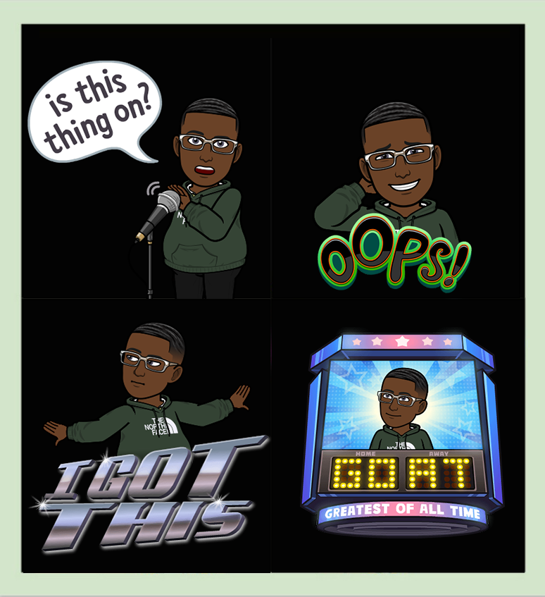
- Graphic Novel Activity Example
  - Students can also follow the 8 Action-Packed Steps to writing a graphic Novel in Resources. “How to Write a Graphic Novel in 8-Action Packed Steps. (Download the steps in the lesson under the Resource Tab.)

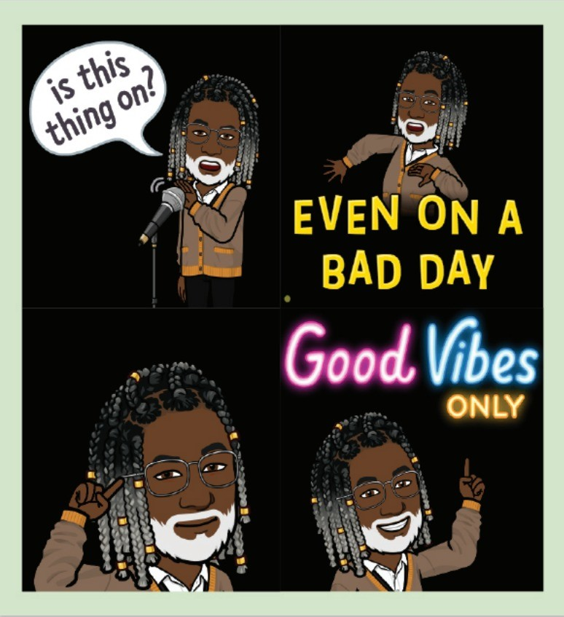
- Tweens: You can also use this resource
  - Creating a Graphic Novel in Google Slides
  - https://www.youtube.com/watch?v=wK9tNcVrGQA

- Tweens: Graphic Novel Activity
  - https://blog.reedsy.com/how-to-write-a-graphic-novel/
  - Follow the 8 Action-Packed Steps to writing a graphic Novel. Or download the template in the resources and jump right into creating your own novel.

#2 - “My Thoughts & Words Have Power”

Opening Experience
Welcome to week 2! Our third Unity Principle tells us that we create our experiences by what we choose to think and what we feel and believe. Our thoughts and words are our power. This week we will explore the power of thought and how we can use it to shape our lives.

We sometimes forget that our thoughts influence our experiences. Today, we will learn how our thoughts work and also how they can work for us or against us.

Activity Choices
- The Scientific Power of Thought
  - https://www.youtube.com/watch?v=-v-IMSKOtoE

- Tweens & Teens: Abundance in Thought Meditation video
  - https://www.youtube.com/watch?v=Nzve1LIrhOk

The Power of Thought – TedTalk
  - https://www.youtube.com/watch?v=MWwhCEx-Eqg

- Positive Thinking Affirmations
  - https://www.clevelandmetroschools.org/cms/lib/OH01915844/Centricity/Domain/7278/101FreePositiveThinkingAffirmations.pdf
  - Use the Positive Thinking Affirmations worksheet by reading them, discussing how they might help, and identifying which phrases would work best for you.
  - Choose your top 10 favorite positive affirmations from the list (or your own) and write them on the worksheet or use your online journal.
  - Everyone can benefit from improving their positive thinking skills! The idea is that by changing your thinking, you can control your emotions and your actions.

Meditation Zone
Let’s pause a moment and explore some ways to help our mind and heart to bring us into alignment with our Spirit. When all parts of us are in sync, we can more easily deal with whatever is happening in our life.

- 5-minute Guided Meditation
  - https://www.youtube.com/watch?v=rZJIsuHITq0

- Journal
  - Capture your thoughts or emotions as you finish your meditation in your journal

- Sacred Table Activity
  - Place an object that represents who you are.

Media Room
What we think and say is important because it affects our lives. We tend to see more of what we are emotional about or what we focus on, or possibly what we give our energy to. Let’s watch this interesting video and learn about the energy of thought.

- The Energy of Thought | Penny Zenker | TEDxPSUBehrend
  - First, find a comfortable spot to check out this Ted Talk. Make sure you have at least 15 minutes to focus and process.
  - https://www.youtube.com/watch?v=lrQ5MJw3mss&list=RDLVMWwhCEx-Eqg&index=3

- Reflection Questions
  - What did Penny Zenker say “Neo” was doing ‘in the moment’?
  - How do we manage our energy?
  - How many thoughts did the National Science Foundation say we have a day?
  - What are some of the thoughts that are repeated in your mind?
  - What is Penny Zenker’s message?
  - What story are you writing about yourself?

Creation Station Activities
Now, let's get creative! We will continue to focus on retelling the moment or experience that you chose in Lesson 1. Be passionate and creative and have fun reimagining your experience.

- Finding your story pt.2 – Use the writing guide in the link to develop a story around a personal experience important moment.
  - https://www.youtube.com/watch?v=UK4hir5lVXg&t=53s

- Tweens: Creating a Graphic Novel - Part 2
  - https://youtu.be/j9CROTuy-js

- Teen: Graphic Novel Activity
  - https://www.youtube.com/watch?v=MWwhCEx-Eqg
  - Add another chapter to your novel - Follow the 8 Action-Packed Steps to writing a graphic Novel. Or download the template in the resources and jump right into creating your own novel.

- You can also use this resource again - Creating a Graphic Novel in
  - Google Slides Comic - YouTube

- Use this web app to help you create your art for your graphic novel.
  - https://www.toonytool.com/

#3 - “I Can Tell a New Story”

Opening Experience
Welcome to week 3! Today we will explore more about how we can tell our stories in a new & positive way. While we can’t change what actually happened, we can use our imaginations to see things differently or from a new perspective. Using these ways of thinking can train our brains to see opportunity instead of misfortune.

Have you ever told a story to someone, and it just brought up bad memories? In this story is there a feeling of guilt or a wish that you could change it somehow? Today we will explore these thoughts and feelings.

Activity Choices
- Personal Timeline Activity
  - Download the handout from within the lesson under the Resource Tab
  - A great activity to view a past experience in a positive way is to create a timeline of the event.
  - Include all the details of the event, as well as any positive outcomes that came from it.
  - Once the timeline is complete, it can be used as a reminder of the event and provide a way to view it from a different perspective.
  - Additionally, the timeline can be used to remind you of the good that came from the experience, and to think about the ways in which the experience could have been different.
  - Finally, it can be used as a source of inspiration for future experiences, as it can help the teenager recognize how much they have already accomplished.

- More Affirmations Activity
  - Download the handout from within the lesson under the Resource Tab
  - Fill out the form to practice your affirmations
  - Supporting Quotes
    - “Remember, the power of the word is yours to wield. Through your words you change the circumstances of your life. Use the magic of the word and remember that the word of God is quick and powerful and accomplishes that whereto it is sent.” ~ May Rowland

- The power of sharing your story | LeRon L. Barton | TEDxWilsonPark
  - https://www.youtube.com/watch?v=OgQJKbUs0Qc&t=271s
  - What if everyone had a chance to tell their story?
  - LeRon L. Barton is a writer and speaker from Kansas City who lives in San Francisco, Ca. He has authored two books “Straight Dope: A 360 Degree Look Into American Drug Culture” and “All We Really Need Is Love: Stories of Dating, Relationships, Heartbreak, and Marriage. LeRon has also published essays and articles about race, mass incarceration, politics, and dating. He has appeared in Al Jazeera, TEDx, Salon, Your Tango, Black Enterprise, The Good Men Project, Speakers Who Dare, and Raconteur. LeRon believes that as a writer, one of his responsibilities is to create, be honest, and encourage others to do so. He is a story advocate who believes everyone’s story counts and we should all share them.

- Teens: Denials & Affirmations Activity
  - Spiritual Principles
    - Denials and affirmations are the tools of affirmative prayer.
    - Denials come first and are used to deny the power that something that is not based in Truth has any power over us. It is not denying that something happened.
    - Affirmations come next and fill the space created by the denial. Affirmations are positive statements of Truth set in the present tense.
  - Supporting Quotes
    - “Remember, the power of the word is yours to wield. Through your words you change the circumstances of your life. Use the magic of the word and remember that the word of God is quick and powerful and accomplishes that whereto it is sent.” ~ May Rowland

Meditation Zone
Take some time to put yourselves in a positive mood. Bringing up old memories and thoughts is stressful. Take 5 minutes to relax and refocus your mind with positive energy.

- 5-minute meditation for positive energy
  - https://www.youtube.com/watch?v=44Ic5XNVFlA

- Journal
  - Capture your thoughts or emotions as you finish your meditation in your journal

- Sacred Table Activity
  - Place another object on the table that represents who you are and your story.

Media Room
Welcome back to the media room. As you watch this video and laugh about how comedy works, also focus on the message being presented of how life works too. Our bad experiences don’t have to be seen as bad experiences, what if they can be a way for us to see our opportunities better?

- More than funny | Michael Jr. | TEDxUniversityofNevada
  - https://vimeo.com/manage/videos/809892568/0f01ad4aa0

- Reflection Questions
  - What did Michael Jr. do to get around his struggles in reading?
  - What does Michael Jr. say practice is?
  - What was the mindset change, that Michael made?
  - What are some mindset changes that you can make?
  - How does he say life works?

Creation Station Activities
Creativity is the best way to change anything from bad to good. Challenge yourself with these tools geared to help you see experiences differently, question situations differently and use them to make positive change.

- Let's play the live game ‘SuperBetter’
  - https://www.youtube.com/watch?v=slJy6NR1Zbg

- Play SuperBetter
  - https://superbetter.com/

- Tweens & Teens: Four Ways of Seeing Activity
  - https://www.youtube.com/watch?v=68b8MMQ374w&t=2s

- Tweens & Teens: Meta-Questioning
  - A great activity to clarify, refine or better understand ideas and problems.
  - This can involve exploring assumptions, implied meanings, values or beliefs.
  - Can be used in a variety of contexts, such as problem solving, decision making and learning.
  - It is a way of building stronger mental models, and ultimately coming to better solutions or answers.
  - https://docdro.id/uAwoqPQ

- Create a Visual Story
  - https://www.photocollage.com/
  - Use one of your important moments or experience you have begun to write about or your experience playing this SuperBetter game to create a visual story.
  - Photo Collage – Use the link to Photo Collage online Cartoon and Comic Strip Maker or use paper, magazine cutouts, etc. to create a physical photo collage.

#4 - “Finding My Voice”

Opening Experience
You have taken steps to realize that you are more than a single story. You know that your thoughts and words have power. You have affirmations to help establish truth within a situation. Now, let’s take a look at how you can tell your stories with your own voice.

The moment you are in, in life consists of so many new experiences and knowing how to deal with them can be challenging. We can’t always control what happens to us, but we can control what we think and say about our experiences.

Activity Choices
- Finding Your Voice From a Kid Who Had Stage Fright
  - https://www.youtube.com/watch?v=JjKF56TwkWI

- My Story 10 years Later
  - Grab some paper and write or use your online journal to record this activity.

- What are my option choices and what am I good at?
  - What I’d like to do when I leave school?
    - What Careers will I do and how much will I earn per year?
      - What would I like to be like as a person?

- Let’s try Smiling Mind
  - https://www.smilingmind.com.au/

- Tweens Teens: Why the teenage brain has an evolutionary advantage
  - https://www.youtube.com/watch?v=P629TojpvDU

- Tweens: Audit Your Social Media
  - https://docdro.id/S8QO21m
  - Use this social media audit template to present or change your story.

Meditation Zone
Creativity comes and goes based on our surroundings or our mood. Let’s pause a moment and do a little practice using our thoughts to change our mood.

- 5-min meditation for creativity
  - https://www.youtube.com/watch?v=l_EhZs72JVA

- Journal
  - Capture your thoughts or emotions as you finish your meditation in your journal

- Sacred Table Activity:
  - Find an object that reminds you of you.

Media Room
In this moment of life, you are in there is also a lot of being told what to do and how to do. It can cause moments of silence, moments where you feel like you shouldn’t speak. Listen to this spoken word about getting stuck in that moment so you don’t lose your voice once you find it.

- The danger of silence | Clint Smith | TED
  - https://www.youtube.com/watch?v=NiKtZgImdlY

- Reflection Questions
  - What was the quote Clint Smith used from Dr. Martin Luther King?
  - What does Clint challenge his students to do in his classroom?
  - What were the four core principles he posted on the board in front of his class?
  - What does he mean when he says “Validation doesn’t need words to endorse its existence?
  - What was the most valuable thing that he thought he could give up?

Creation Station Activities
Albert Einstein once said, “Creativity is intelligence having fun.” Have fun finishing your stories and retelling your experiences to yourself or others.

- Finishing your story – Continue to use the writing guide in the link to finalize your story around a personal experience important moment.
  - https://docdro.id/SFVNlpy

- Life Experience Poem
  - https://docdro.id/AUyC6G0
  - In the Media Room video Clint Smith talked about having his students write their truth using poetry.
  - Poetry often brings out different and varying feelings about something that we may previously hadn’t thought of.
  - Jump write in and start writing, typing or follow the guide in the form to help you organize your thoughts.
  - Download the form from inside or from the resource tap and open if you would like to fill it out and save it.

- Finish Your Graphic Novel
  - https://www.toonytool.com/
  - Or let a loved one hear or read your story.

- Tweens Teens: Social Media Stories
  - https://www.humanetech.com/youth/tell-your-social-media-story
  - Add stories to your social media
  - Or let a loved one hear or read your story.

