  - Gratitude Unit

Unit Overview
Unit Focus:
The intention of this unit is to understand that when we acknowledge the blessings in our life, however small, we notice them more and more and we see how rich our life really is.

Unit Outcomes: By the end of the Unit learners will be able to:
- Identify the good that surrounds us.
- Know that the more we acknowledge the blessings we see, the more we experience.
- Understand that even the smallest thing is a blessing if it is given freely from the heart.

Unit Weekly Themes:
- Appreciating Self
- Appreciating Others
- Appreciating Community
- Appreciating Nature

Affirmations
- I see only good everywhere I look.
- I am grateful!
- I appreciate the world around me and how it supports me every day of my life.
- I speak only words of gratitude and praise as I create a world of abundance and equity.

Bible Quotes
- So then let us pursue what makes for peace and for mutual upbuilding. Romans 14:19

- Bear with each other and forgive one another if any of you has a grievance against someone. Forgive as the Lord forgave you. Colossians 3:13

- Love is patient, love is kind. It does not envy, it does not boast, it is not proud. It does not dishonor others, it is not self-seeking, it is not easily angered, it keeps no record of wrongs. Love does not delight in evil but rejoices with the truth. It always protects, always trusts, always hopes, always perseveres. 1 Corinthians 13:4-7

Unity/Fillmore Quotes
- Talks on Truth p9.
God is Spirit, infinite Mind, the immanent force, and intelligence everywhere manifest in
Nature.

- Revealing Word p89
Gratitude is a great mind magnet, and when it is expressed from the
spiritual standpoint it is powerfully augmented.

- Dynamics for Living p156
Words that express thanks, gratitude, and praise release energy of mind and soul. Their use is usually followed by effects so pronounced that they are quickly identified with the words that provoke them. Let your words of praise and thanksgiving be of Spirit.

- Prosperity p105
Be thankful for every blessing that you gain and as deeply grateful for every demonstration as for an unexpected treasure dropped into your lap. This will keep your heart fresh; for true thanksgiving may be likened to rain falling upon ready soil, refreshing it and increasing its productiveness.

Children’s Lessons

#1 – Appreciating Self

Opening Experience
Welcome to the first week of our month of gratitude! This week we will begin by exploring what we appreciate about ourselves. Click on the gold stars that are placed around the room to find LIFE POWER and an activity sheet where you will reflect on what an affirmation brings up for you. Then give yourself a high five by listing five special things you love about yourself. Don’t forget to grab a journal for the journey, where you will share notes from activities so you can look back at who you are and how you feel right now. So grateful you’re here!

Activity Choices
(3 Handouts attached below)

  - Life Power and You Handout
  - 5 Things I Like About Me Handout
  - A Journal for the Journey Handout

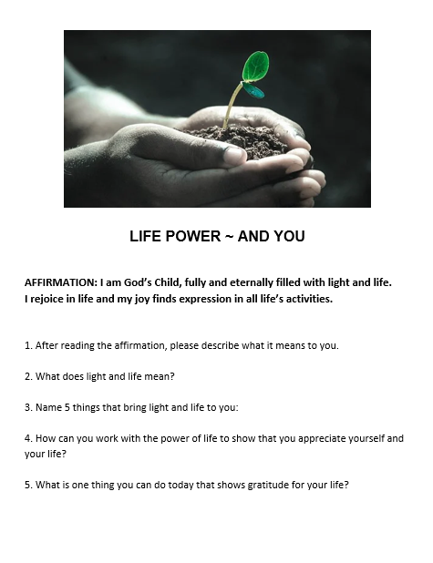
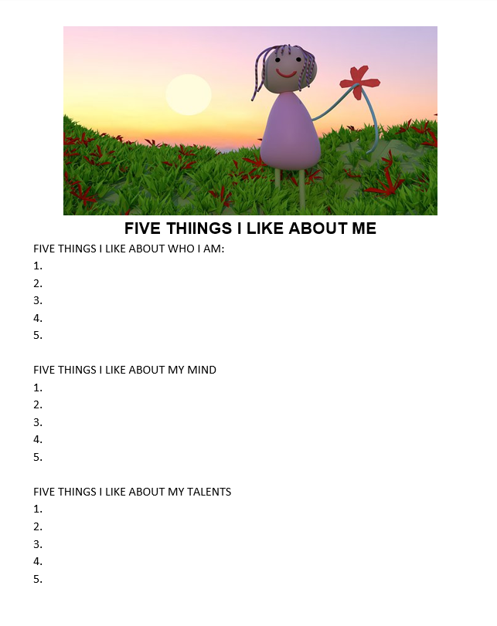
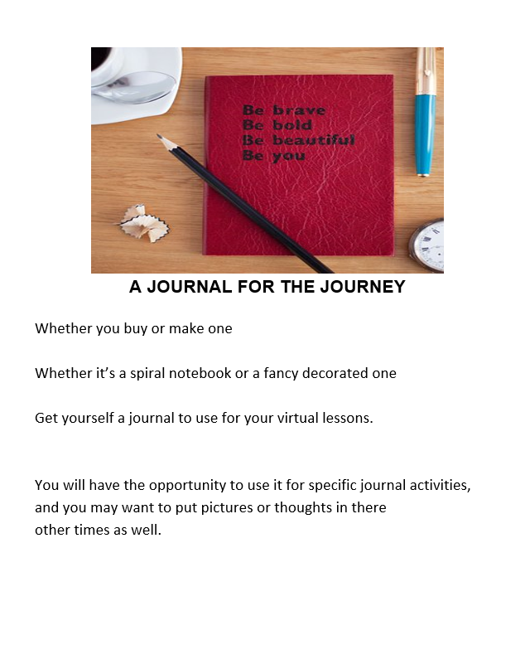

Meditation Zone
Now, it’s time to relax with some meditative activities. Watch the meditation and then complete a fun activity to find the glow you carry, reflected in objects around you. Then, you will be asked to find a light source that you can use as a reminder of the Christ Light within you. Deep breath and enjoy.

Activity Choices

- I am the Sun Meditation
https://www.youtube.com/watch?v=diRO5faOz8M
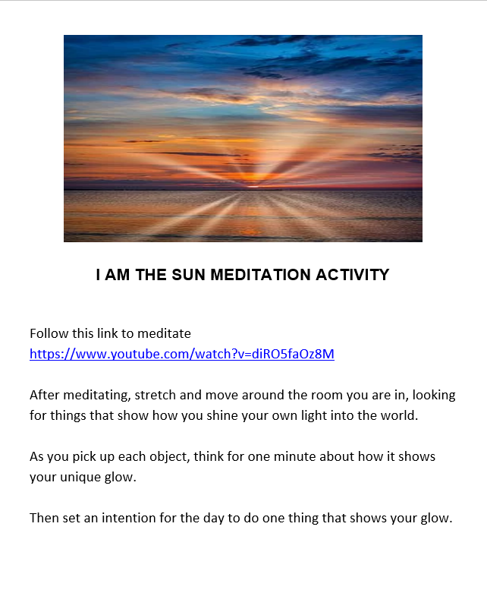

- Show Your Glow Handout
https://www.youtube.com/watch?v=diRO5faOz8M
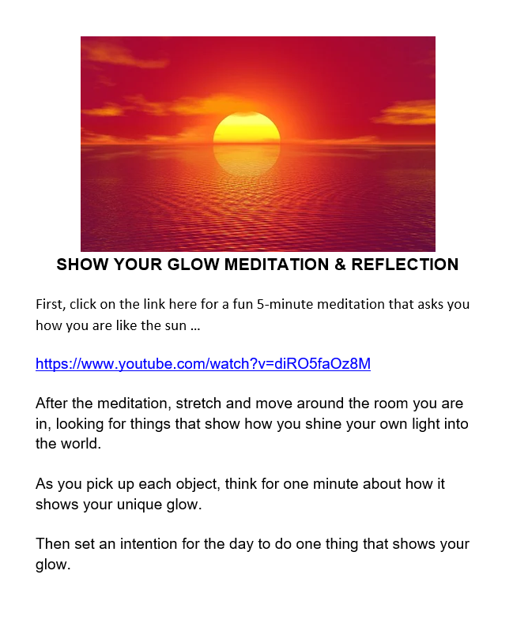

- Light the Night Handout
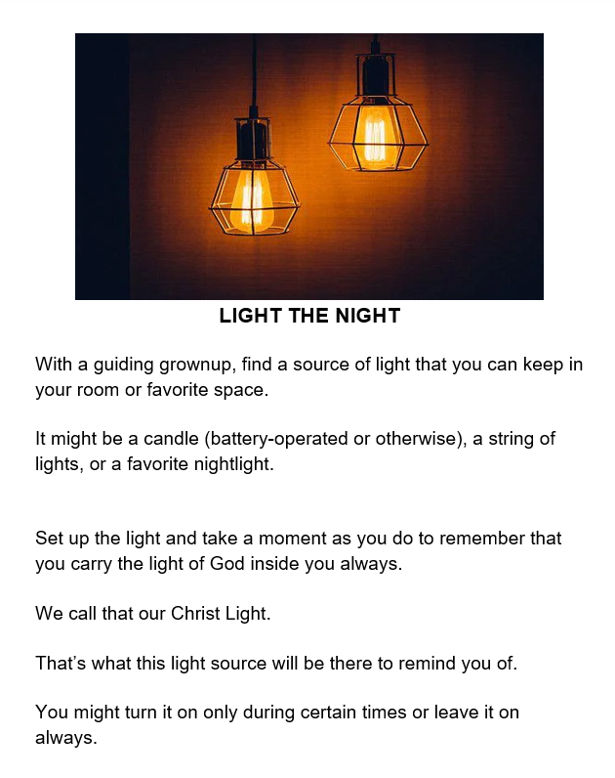

- Sacred Table Activity:
  - Find a candle to place on your sacred table to remind you of the Christ Light within you.

Media Room
Welcome to the media room! Watch the video to hear a great story about being yourself, and spend some time exploring what it brings up for you. Then, you can dance around to a great song about being all we can be with an attitude of gratitude. Enjoy!

Today we will watch the video: Remarkably You by Pat Zietlow Miller
- https://youtu.be/zQqFhOKUqCo

Reflection Questions
- Describe yourself: Are you loud and bold? Timid, and shy? Or something in between? What is it about you that makes you feel that way?
- How old are you, and when is your birthday? Do you think you are small, or practically grown? Why?
- What is it about you that makes you a surprise?
- What are some dreams you wish to come true?
- What gifts do you bring to the world, and what can you do to share them?

Thankful by The Juicebox
- https://www.youtube.com/watch?v=YeSdQmO51Ps

Creation Station Activities
Now let’s get creative! You will find instructions to make your own gratitude board. Then, go on a scavenger hunt, hunting all around your area! Thank you for being you and showing the world your creativity!

- Gratitude Board Handout
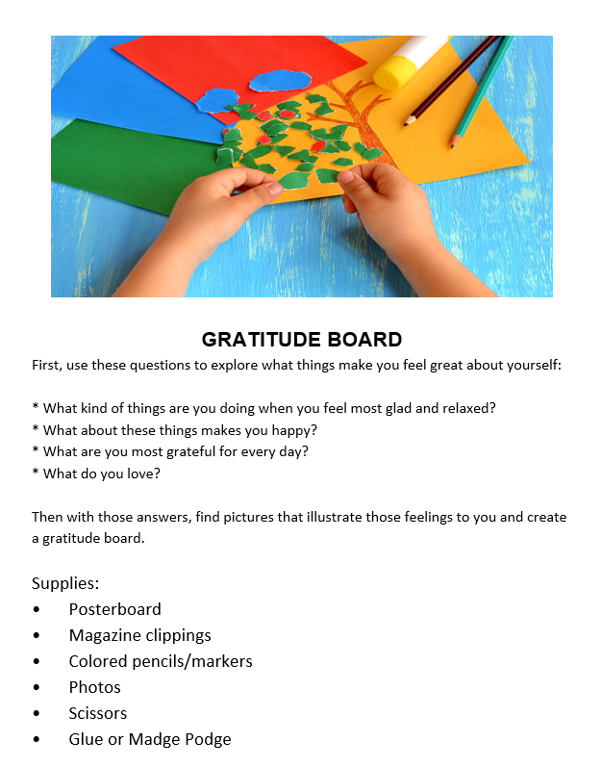

- Scavenger Hunt Handout
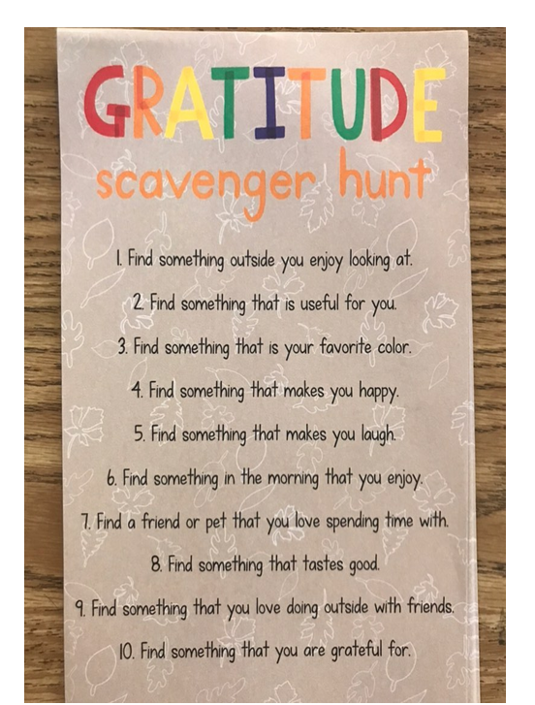

#2 – Appreciating Others

Opening Experience
We are so grateful you have joined us for week 2 of our gratitude exploration. Come on in! As you click on the stars this week, you will have some fun making your own thank-you notes, exploring the divinity in everyone around you, and then thinking outside the box, to show gratitude in action for someone you love. How cool is that? Now go on, jump right in!

Activity Choices

- Thank You Notes
https://www.connectionsacademy.com/support/resources/article/how-to-teach-kids-write-thank-you-notes
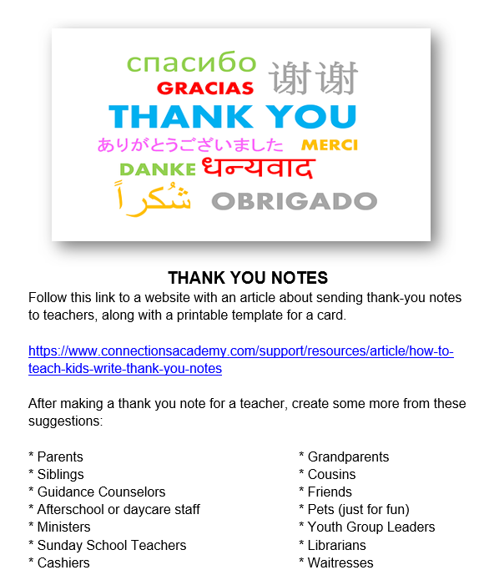

- Life Power Handout
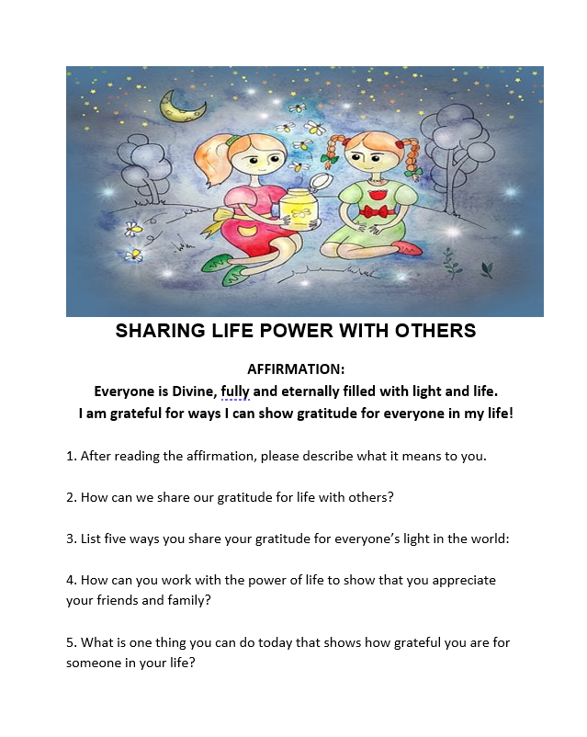

- Think Outside the Box Handout
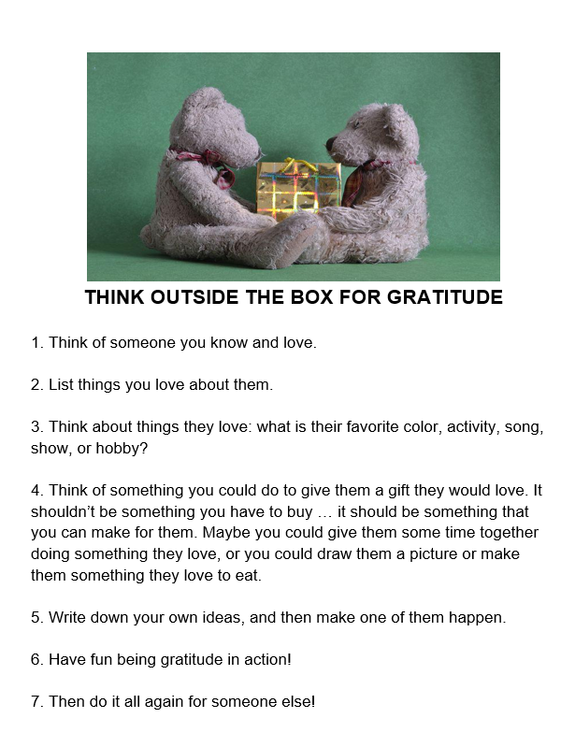

Meditation Zone
Welcome to the media room, time for a time out! Sit back, relax, and after you enjoy the meditation, grab your journal, and write about the feelings you experienced. Then, with the permission of a grownup, check out some great, free apps that you can download to help make meditation part of your daily routine.

- Gratitude Meditation
  - https://www.youtube.com/watch?v=Bs2P0yrIjT4

- Meditation Reflection
  - What family member did you picture in your mind? What did you think of that you were grateful for about them?
  - What friend did you think of? What are you thankful for about them?
  - What teacher did you think of? What came up for you that you are grateful for about them?
  - What 3 things did you think of that you are grateful for?
  - Can you think of more?
  - Draw some of them!

- CHECK OUT THOSE APPS!
  - Follow the link to research some great kids’ meditation apps, and then maybe sign up for one or more and meditate!
  - https://www.understood.org/en/articles/8-meditation-apps-for-kids

- Sacred Table Activity: Add an item to your sacred space that you are grateful for or is a reminder to be mindful of gratitude.

Media Room
Welcome to the media room! Find a fun thank you song to dance to, relax a bit with a story, and then grab your journal to reflect.

- The Thank You Letter story
    - https://youtu.be/O6QnpAwSuPk

- Reflection Questions
- How did you like how he read the story?
- What was it about?
- What kinds of things did Grace want for her birthday? What kinds of things would you put on your birthday list?
- Who did Grace write thank you letters to, and what kinds of things did she write?
- Who would you write thank you notes to for things you are grateful for?
- How many do you think you could write?
- Who wrote all the love notes to Grace, and how do you think she felt about them?
- What did she do after she received them?
- What do you think you could do right now after reading Grace’s story?

- Gratitude Song with the Storybots
  - https://www.youtube.com/watch?v=6F2VDKkw1qU

Creation Station Activities
Welcome to the creativity station! This week we will have fun creating gratitude dice, watching a heroic video by Kid President, and then exploring what comes up for us after we listen to and watch a thank you song. Get inspired and have fun!

- Gratitude Dice Handout (See handout below)

- “A Little Thank You” Song
  - https://youtu.be/_bxZ6joLWCM?si=T_idFs5af1-NDglI

- Kid President 25 Reasons to be Thankful.
  - https://youtu.be/yA5Qpt1JRE4

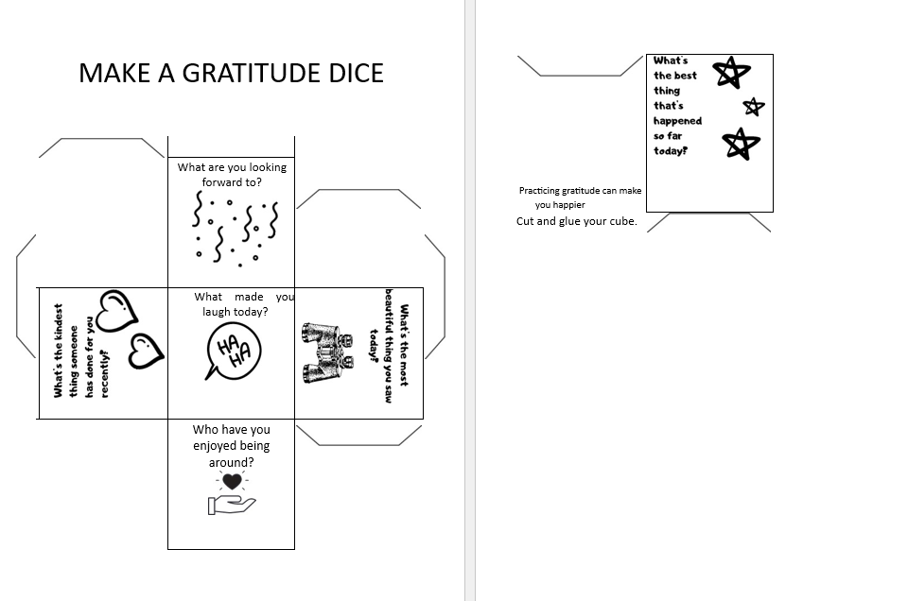

#3 – Appreciating Community

Opening Experience
Week 3 already? Thank you so much for coming! As you move around the room this week clicking on the stars, you will find a worksheet to complete about community service, a fun bingo game, and then some Unity basics you can reflect on. We hope this will inspire you to reach out and show your gratitude to those in your community who help!

Activity Choices
- Community Service Handout
https://www.education.com/worksheet/article/what-is-community-service/?epik=dj0yJnU9LVZDX1hycUtMeHlCa1U5REJRT3M1QTNGMHJCYlRjbmImcD0wJm49czJqM3QxdG1CRF9fcmRaNk1lbUJ6QSZ0PUFBQUFBR0

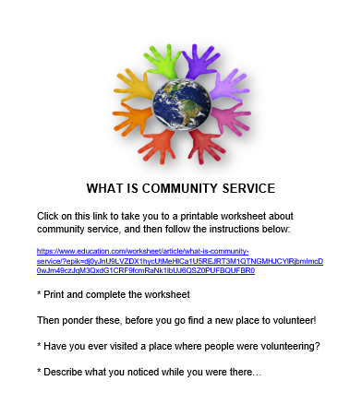

- Unity Basics Handout
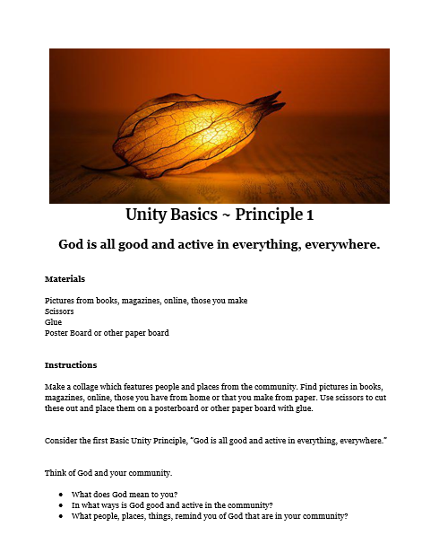

- Community Helper Bingo Handout
https://funlearningforkids.com/community-helpers-bingo-alphabet-activity/

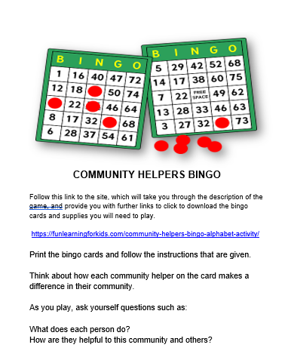

Meditation Zone
Now it’s time to meditate. You will find different meditative experiences from a dancing meditation in gratitude to creating a delicious gratitude experience with fresh foods. It will be delicious!

- Thank You Farmers – Blippi’s Playhouse
  - https://youtu.be/jqqlS9IA4nU

- Thank You Farmers Meditation
  - Find yourself a safe place to listen, move, and meditate.
  - Take a few deep breaths, and feel your heart opening in gratitude
  - Stretch your body to be ready to move as the music moves through you
  - Click on the link: https://www.youtube.com/watch?v=jqqlS9IA4nU
  - Only close your eyes if you are in a safe space, and move your body with the words and music
  - Feel yourself relax and enjoy
  - Write or draw a picture about your experience in your journal

- Fresh Food for Gratitude
  - With a grownup, find some fresh food ~ maybe fruit, maybe vegetables, whatever you love most and is available in your area.
  - Make a dish to share using your fresh ingredients.
  - Say a prayer of gratitude for all the hands involved in bringing this food to you so you can prepare
  - Share your food with friends or family, sending blessings to everyone that it took to bring it to you.
  - BONUS ITEM:
    - If you have the room and supplies, plant some seeds so you can grow your own food!

- Sacred Table Activity
  - Take some time to reflect and add a memento to your sacred space that represents community helpers that you’re especially grateful for.

Media Room
Hello from the media room! You will find a song where everyone shares their attitude of gratitude, listen to a story about what a community is, and then dive into what things you can do to show gratitude for your community.

- Look Where We Live
  - https://youtu.be/B2lM2y5DODc

- Reflection Questions
  - What do the five friends and their pets do in this story?
  - What is the street fair for?
  - What is a community?
  - What things do you do in your community?
  - Have you ever had a yard sale?
  - Have you ever donated anything to a good cause?
  - Have you ever had a car wash? Do you think you could?
  - Could you organize a community cleanup?
  - Have you ever seen a mural on a building?
  - How could you work together with people to help your community?
  - Do you have an older relative that lives near you? If so, what can you learn from them?
  - What would you grow in a community garden?
  - What jobs can you name that make your community safe?
  - What communities are you a part of?
  - What are some ways you can help others around you?

- Gratitude Attitude Song
  - https://youtu.be/Ir7SIxwtoyM

Creation Station Activities
So glad you’re here! You will find some information about community service projects, fun math games to choose from, and a number of gratitude games. Ready, set, GO!

- Community Service Project Handout
  - https://blog.reallygoodstuff.com/12-community-service-projects-for-kids/
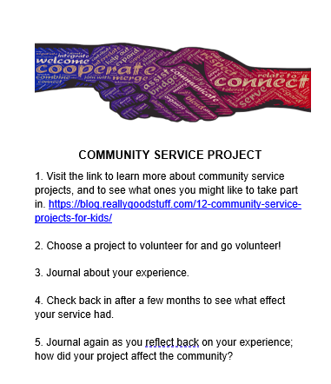

- Math Games Handout
  - https://www.pinterest.com/pin/10485011619500200/
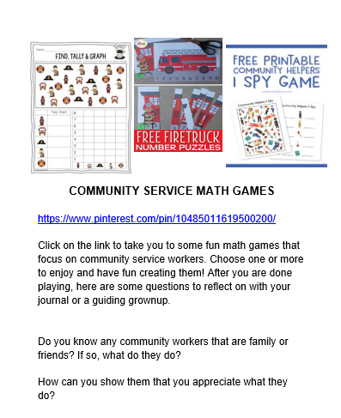

- 3 Easy Gratitude Activities for Kids
  - https://youtu.be/YHxMo6cRmfs?si=WP_yENEaGmhW277L

#4 – Appreciating Nature

Opening Experience
This week, you will find yourself appreciating all the wonders of nature. You will find a nature appreciation walk, directions on how to make a pinecone bird feeder, and an exploration of Unity’s first principle with a focus on the natural world. You’re sure to walk away from this week really in touch with all there is to be grateful for on our planet, and with Mother Earth!

Activity Choices

Nature Appreciation Walk

https://www.education.com/worksheet/article/nature-appreciation-walk-showing-our-gratitude-towards-nature/

- Pinecone Bird Feeder Handout
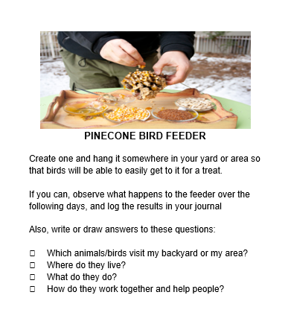
- Nature Activity Sheet

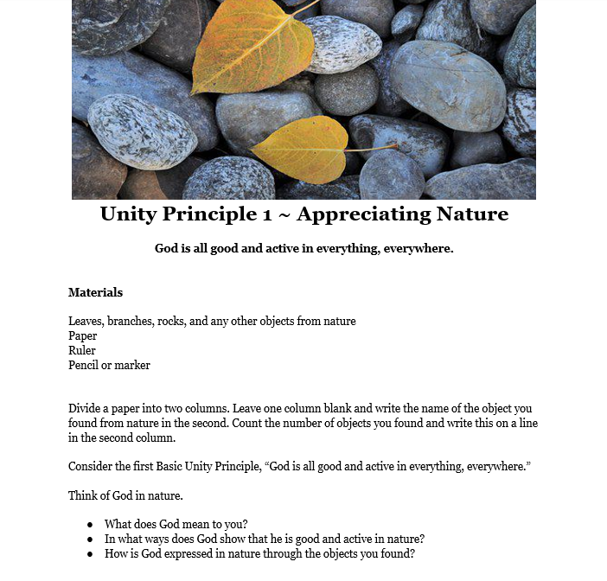

Meditation Zone
In the meditation room, you will climb mountains! First, the mountain of meditation, then grab your journal to answer some questions about your experience, and then create your meditation mountain. You can go back to any time you feel like you need a moment of peace.

- 5 Minute Mindful Meditation
  - https://youtu.be/87AJFb2BqRc

- Meditation Reflection
  - The meditative voice suggested a way for you to sit while you meditated. What is your favorite way to sit or lay down for meditation?
  - What did you notice about your breathing?
  - What does the energy in your body feel like?
  - What did the view look like from your mystical mountain?
  - What does it feel like to look down on the clouds?
  - What does it feel like to feel your thoughts as though they are floating by like clouds?

- Make Your Mountain Handout
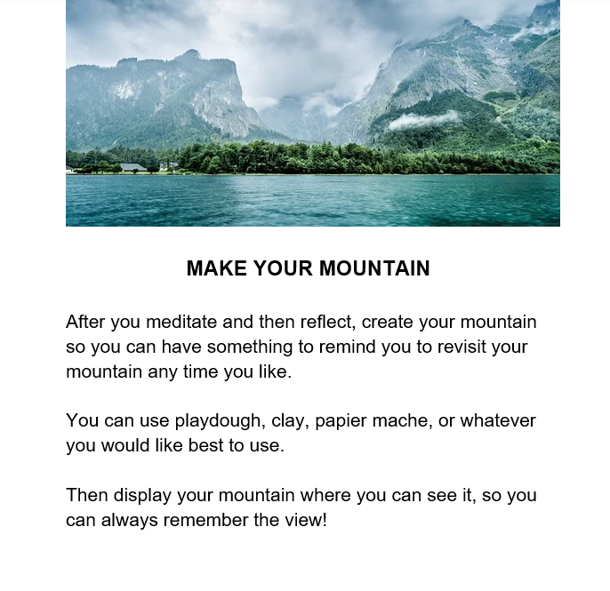

- Sacred Table Activity:
  - Reflect on the voice and thoughts in your head while you meditated. Place an item in your sacred space that is a reminder of some of those peaceful thoughts that you experienced.

Media Room
In our media room this week, you will find a great story about what someone can find when they take a walk in nature. Then as you reflect on the story you will journal what you would find on your own walk. After that, you can enjoy the Attitude of Gratitude song.

- I Took a Walk
  - https://youtu.be/8au_mPa0TKc

- Reflection Questions
  - What would you find if you went for a walk around where you live on a spring morning?
  - What kind of birds, creatures, and bugs live around your neighborhood?
  - What kind of water would you find in the nature around your house? (Streams, ponds, rivers, oceans?)
  - What things do you see in your quiet place to sit?

- The Attitude of Gratitude Song
  - https://www.youtube.com/watch?v=DCjricfncNE

Creation Station
Ah, creative time! You will find a do-it-yourself nature memory, match game, a nature weaving craft, and also a great video with some exciting ideas that you can put into practice to take care of the amazing planet we call home. Take a deep breath, put on your walking shoes, and have a great time!

- Nature memory Game Handout
  - https://rhythmsofplay.com/diy-nature-memory-game/
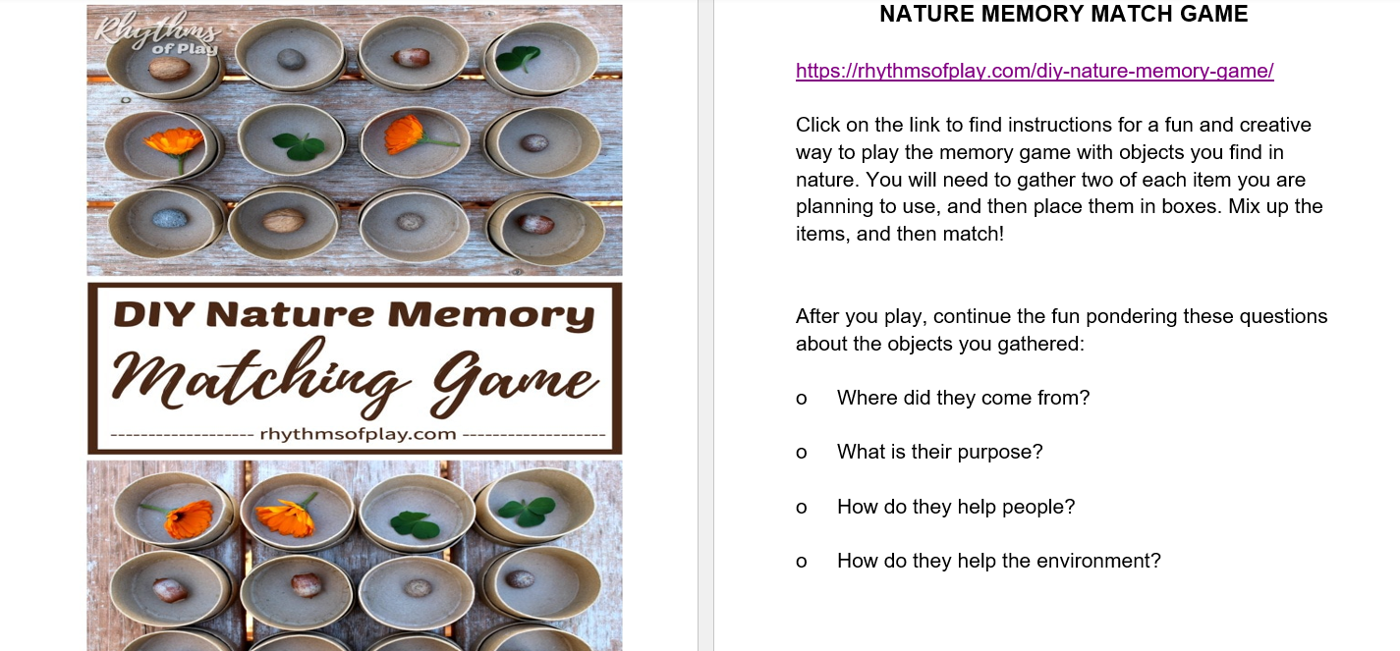

- Nature Weaving Handout
  - https://www.kidssoup.com/craft-and-resource/im-thankful-for-nature-weaving-craft
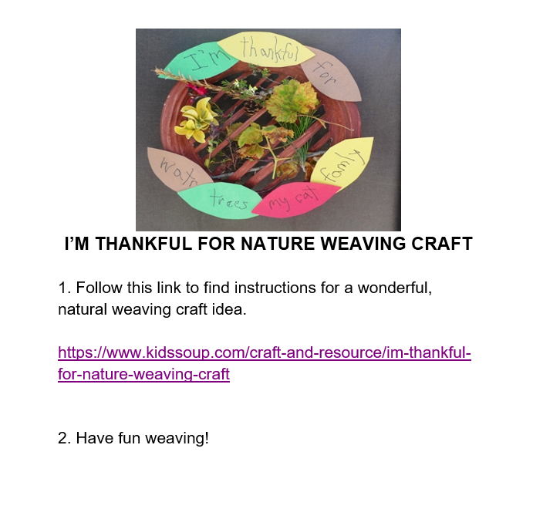

- How to Care for the Environment Song
  - https://youtu.be/belXC_IoW4o

Tweens & Teens Lessons

#1 – Grateful for Me

Opening Experience
Welcome to gratitude! During these weeks we will explore gratitude from all angles and have a blast doing activities that are designed to increase thankfulness in our lives. This week we learn to be grateful for ourselves. You will find a worksheet about people you admire that has a secret twist at the end, and then a chance for a high five in gratitude. Then there is a reminder to make sure you have a journal for the journey with a great opportunity for some self-care.

Activity Choices

- People I Admire Most Worksheet
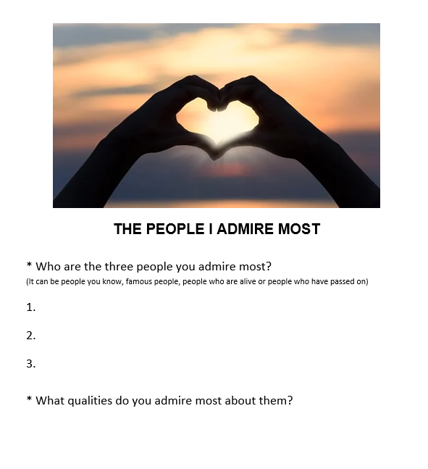

- My High Fives
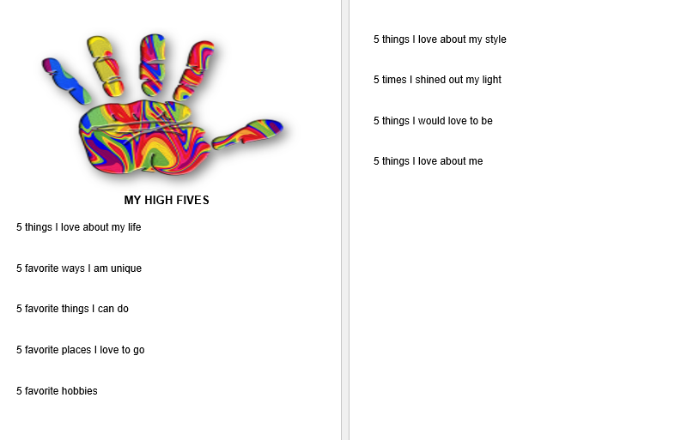

- Journaling the Journey
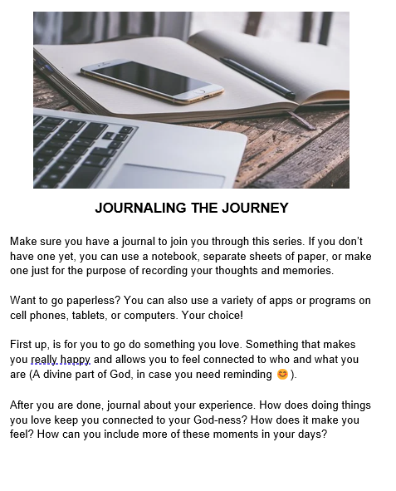

Meditation Zone
Take a deep breath, relax, and move into some great meditative possibilities. Do a 5-minute body scan meditation that will remind you that you are more than the thoughts that run through your head. Lastly, you will find a song to enjoy that will help you be you!
- Find a quiet, comfortable place for a 5-minute meditation.
- Get into a comfortable position, and then click the link to begin.
- After the meditation, grab your journal and write or draw about what you noticed and experienced about your body in this meditative time.

- 5 Minute Body Scan
  - https://www.youtube.com/watch?v=z8zX-QbXIT4

- You Are Not Your Thoughts
  - https://www.youtube.com/watch?v=0QXmmP4psbA

- Sacred Space
  - As we create our virtual sacred space, create one at home! Add a rainbow, bubbles, or an item of your choice to remind you to breathe.

- Jordan Smith – “Stand in the Light”
  - https://www.youtube.com/watch?v=fgXRzjlbbng

Media Room
Welcome to the media room! Today, you get to decide whether you are a glass-half-empty or half full kind of person. Or maybe you will realize the glass is always full of something; sometimes liquid, sometimes air, or maybe even Spirit! Take a song break with a hit by Lauren Daigle that recognizes that God is speaking from within about who and what you are. Enjoy!

- Is Your Glass Half Empty of Half Full?
  - https://www.youtube.com/watch?v=V9xhpLpZZSg

- Reflection
  - How do your strengths serve you when troubles come up?
  - How can you build on these strengths?
  - What are you grateful for about you?
  - What difference do you think it makes for the people in the video, or for you, if you focus on strengthening your strengths instead of focusing on your weaknesses?
  - How would your life be different if you spent time celebrating life’s great points (instead of focusing on the yucky parts?)?

- “You Say” by Lauren Daigle
  - https://www.youtube.com/watch?v=oZvKJl1kK8g

Creation Station
Ready? Set? GLOW!Our creativity station that will lead you to a variety of glowing activities to remind you about your light. But that’s not all! Take a moment to tune into your talents with a questionnaire that might help you find what makes you feel most alive and source-connected.

- Tune Into Your Talents Handout
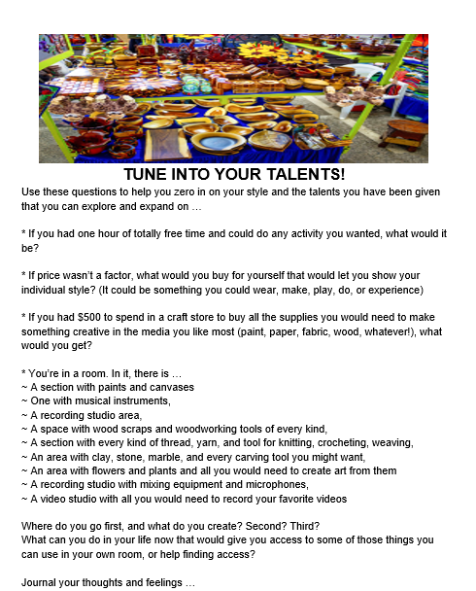

- Ready, Set, Glow!
  - https://www.youtube.com/watch?v=H63OIAuohTc

#2 - “Finding Inner Strength.”

Opening Experience
Welcome to the second week of gratitude! This week we will explore community. You will find some great ideas and resources for community service projects, some places to go for information about Unity, and a love-provoking thank-you card project. How do we contribute to our community so that it becomes an extension of our heart? Dive in, find out, and then go for it!

Activity Choices

My Unity Community
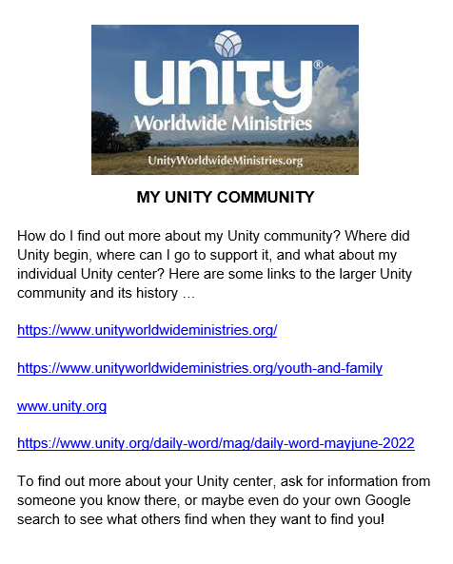

- Community Service Projects
https://www.youtube.com/watch?v=vgULvFKqJjk
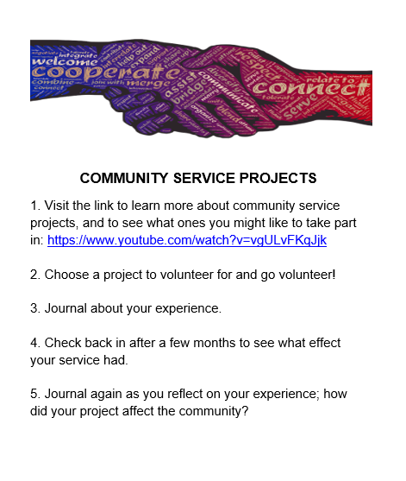

- Thank You Cards
https://www.messylittlemonster.com/2020/12/printable-thank-you-card-pop-art-kids.html
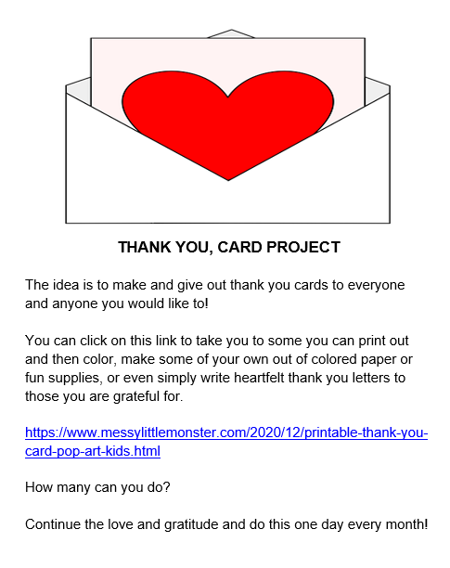

Meditation Zone
Meditation time! Enjoy a togetherness meditation, and prayer practice, then create a chain of gratitude. Release, relax, and rejuvenate your gratitude practices.

- Togetherness meditation
  - https://www.youtube.com/watch?v=Ocf3SbdguJE

- Reflection
  - 1. Get some paper and clear tape or staples.
  - Cut the paper into thin strips.
  - Grab crayons, colored pencils, markers; whatever you want to use to decorate.
  - On each strip, put the name of someone or something you are grateful for (family members, friends, community workers, spaces, places, animals, songs, games ~ whatever you like)
  - Make the first piece of paper you have decorated into a circle, and fasten it closed.
  - Every other piece, after it is decorated, will slide through the piece before it. Then fasten that into a circle and create your chain of gratitude.

- The Gratitude Experiment
  - https://youtu.be/U5lZBjWDR_c?si=18JByAU6ypYNWoq8
  - Make a gratitude list for a week
  - Pick one item off it at the end of the week
  - Write a letter to the person who is responsible for that thing
  - Mail, email, text, read, or somehow send the letter to them.

- “Thank You” Fearless Soul
  - https://www.youtube.com/watch?v=Ahhvab1qFCs

- Sacred Space
  - Write a letter of gratitude to yourself. What’s an opportunity/gift/moment or who is a person you are thankful for?

Media Room
In the media room this week we have an old school song about how we all are a part of the world community. If you’re interested, search it up after you hear and find out why it was written, and why all those mega stars (that your parents will surely know, even if you might not) came together to record it. Then check out a video about a gratitude experiment you are invited to take part in yourself!

- Gratitude Experiment
  - https://www.youtube.com/watch?v=oHv6vTKD6lg&t=367s

- Reflection
  - Who is someone influential in your life?
  - Write them a letter of gratitude.
  - Call them and read the letter or send it to them in the mail, by email, or by text.

- We Are the World
  - https://www.youtube.com/watch?v=s3wNuru4U0I

Creation Station
Gratitude rocks! You’ll find out as you click around, that you can take that literally and create some beautiful rock art to spread around. Then, be gratitude “in action” as you think outside the box about how to show appreciation for others. Have a blast!

- Thinking Outside of the Box
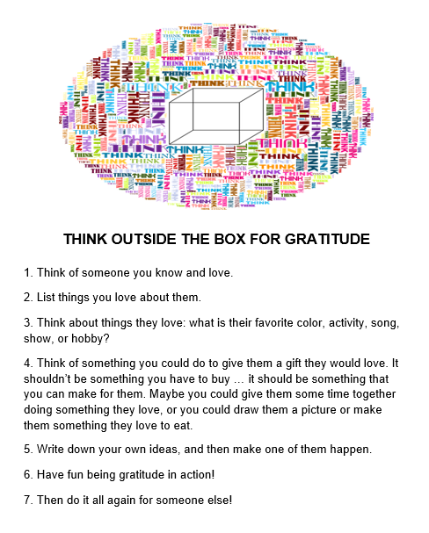

- Gratitude Rocks
  - https://resources.finalsite.net/images/v1586211497/santacatalina/hptxrlhynxqf3vzafnmk/LMS_SpringBreak_GratitudeRocks.pdf
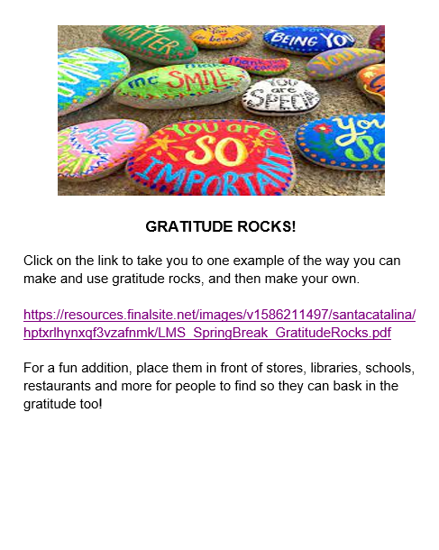

#3 – Grateful for Possibility

Opening Experience
Hello from week 3! This week we ask, “How does my belief and expectation shift what shows up in my life?” In that answer a powerful force for creation allows us to change the very fabric of our life. So, take part in a time-honored tradition called vision boarding, get help with some great ways to set goals especially for teens ~ and maybe most important of all to help us through life, learn what an effective support system looks like and how you can set one in motion for yourself.

Activity Choices

- Out Picturing Gratitude
  - https://www.youtube.com/watch?v=YcntJImMNNA

- My Support System
  - Here you will find a great article about what a support system is, how to create your own, and how to keep it current.
  - https://courtneyharriscoaching.com/real-talk-for-teens-naming-your-support-system/
  - Here’s a great video! https://www.youtube.com/watch?v=GBKNkswW_3M
  - After you check out the article and video, decide how you will proceed to create your own support document, and what you will fill it with. Refer to it if you ever need self-care help and keep it current as you go forward. Support rocks!

Grateful for Goals
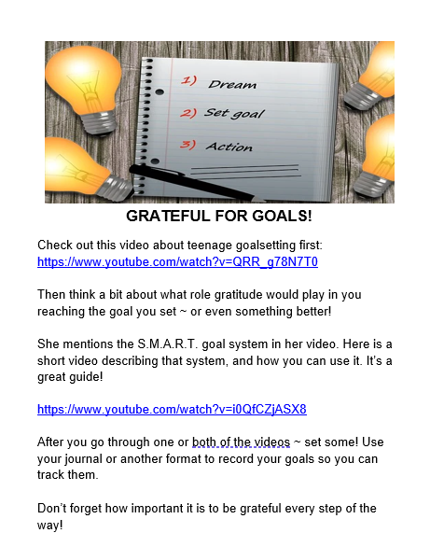

Meditation Zone
Ah, self-care! This week you will find meditation is downright poetic. Dive into self-care awareness that will hopefully lead you toward integrating some of those practices into your life. Then, sit for a moment in song with India Arie to remember that you are light too. It will make all this difference to how grateful you feel!

- Gratitude Poem Meditation
  - https://www.youtube.com/watch?v=qGXt37PfyiI

- Reflection
  - First, find a comfortable place to spend a few moments watching the video in a meditative mood. Relax.
  - Get comfortable, take a few deep breaths, and then hit play.
  - Breathe evenly and listen. Pay attention to how you feel and what comes up in your when she says the words.
  - After meditating on the video poem by Natalie Patterson, write your own! It doesn’t have to rhyme; it just needs to be an expression of your heart.

- India Arie “I am Light”
https://www.youtube.com/watch?v=OL-gxfx2QtY

- Sacred Space
Place an item in your sacred space to remind yourself of the inner light you carry.

- Self-Care Awareness (Handout Below)
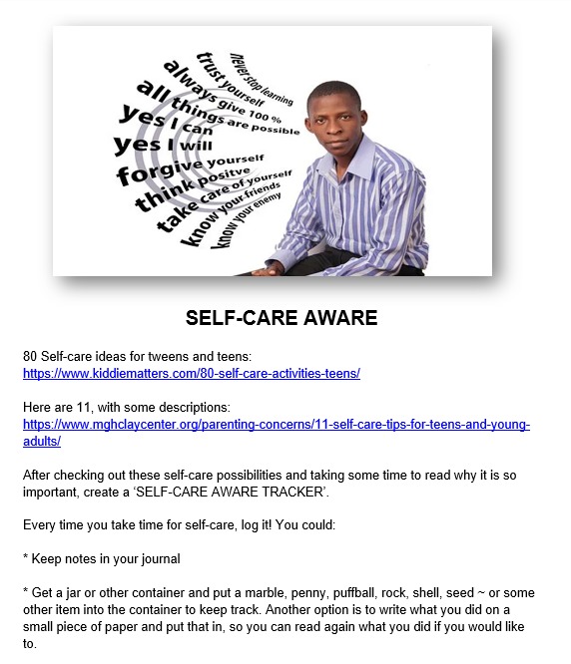

Media Room
Prince Ea is a social media activist sensation that touches the hearts and minds of tweens, teens, and adults alike. His videos are challenging, transformative, and totally awesome. After you click onto his video about being yourself and move through the discussion questions, make sure to check out some of his other media to help you think and grow.

- Be Yourself by Prince Ea
  - https://www.youtube.com/watch?v=UB7nGT3egak&t=130s

- Reflection Questions
  - How do you feel about being popular?
  - What do you think about others who are popular or well-known?
  - In what ways do you think your life would be different if you cared, or didn’t care, about what others think of you?
  - How do you feel about people being loved for being fake?
  - What can you do more to be your real self?
  - When do you feel your happiest?
  - What things can help you have the courage to be you?
  - What things that you do make you feel like shining?
  - What things can you do to focus on you being your best self?

- A Million Dreams by Pink
  - https://www.youtube.com/watch?v=L7TN0hyONjw

Creation Station
This week in the creativity station, let’s roll some dice to explore possibilities and learn about using a dream jar. Then use Google Maps to help you chart your course to new horizons that will have you counting more and more blessings as you go. Joyful journeys!

- Dream jar
  - A dream jar is a fun and creative way to itemize your dreams. You can leave the jar to simply look back on later, or you could use it to plan things you want to do.
  - Check out this video to get you started so you can create your own and use it however you like!
  - https://www.youtube.com/watch?v=cbMZOOXnBDc

- Rolling the Dice for Appreciation (See handout below)
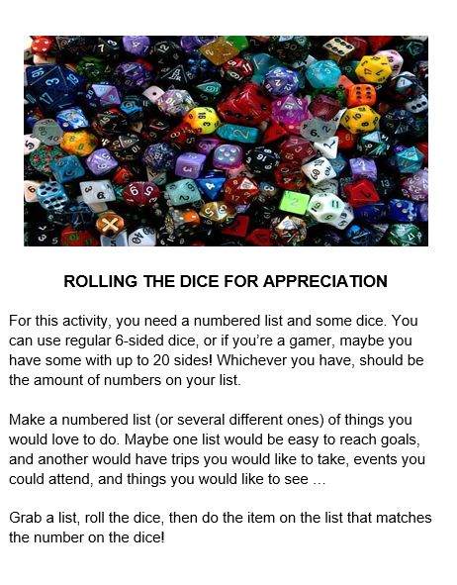

- Grateful for the Journey
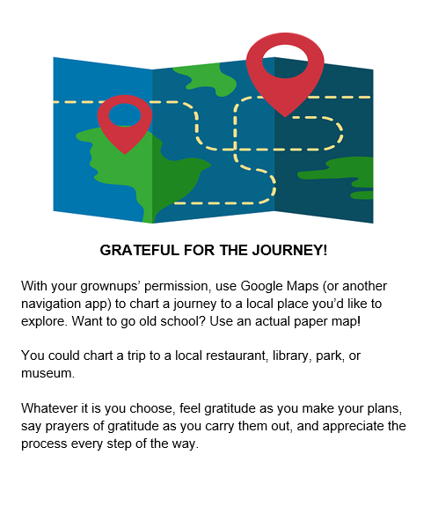

#4 – Grateful for My World

Opening Experience
Welcome to the final week of our gratitude exploration. What could be more important than
ourselves, to be grateful for than the planet we call home? You will find links that will show you what is so special about our planet in comparison to others, then step into some out-of-school- quiz fun to find out what challenges our planet faces, and how you can help. Then just for fun, take a quiz to find out what element you are.

Activity Choices

- What’s So Special About Earth?
  - https://www.youtube.com/watch?v=lTTXzdqzMi4

- Earth Day Quiz
  - How much do you know about what our earth is all about, and what we do to help or hurt it?
  - This site has lots of short quizzes to learn all about many parts of the earth care puzzle, followed by some activities you can do to help.
  - https://www.earthday.org/earth-day-quizzes/?gclid=Cj0KCQjwpv2TBhDoARIsALBnVnlyVAPNA56hOpiOUUTHLf4PvTd74gw5mXt3cwIZF2qw25MqYn9UpyoaAu4BEALw_wcB

- What’s My Element Quiz
  - On our planet, we have four elements: water, fire, earth, and air.
  - Which one are you?
  - Take this fun quiz to find out what your personality element is.
  - https://www.youtube.com/watch?v=Fisr4YY_2L8

Meditation Zone
Embrace yourself for these virtual beach and forest walk meditations. Then, stroll around outside to determine what you can do to help our environment thrive.

- Beach Walk meditation
  - https://www.youtube.com/watch?v=-UZqt90v4-s

- Forrest Walk Meditation
  - https://www.youtube.com/watch?v=doyZLqH_wgM

- The Nature Where You Live (See handout below)
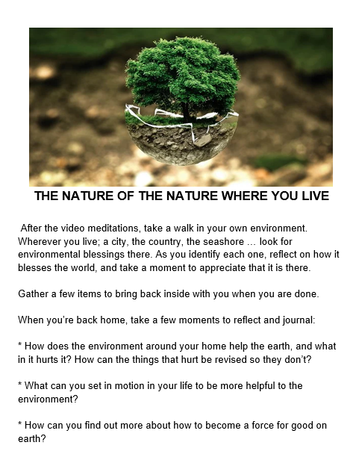

- Sacred Table
  - Add an item or two from your nature walk to remind you to be grateful for your community and world.

Media Room
We can often take for granted how things are. Sometimes it can help to see the enormity of what we are a small part of. This would help us realize the trillions of teeny tiny blessings that are absolutely everywhere, if we simply take the time to notice them. You will find some videos that show just how immense the galaxies in our universe are. Then journal about your thoughts while listening to a song about being grateful.

- I’m Calm/Jayneen Sanders
  - https://youtu.be/665FfQRI2z4

- The Magnitude of Gratitude
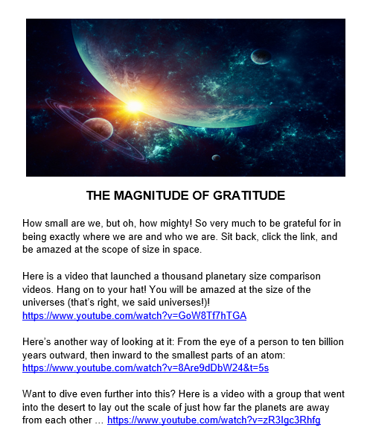

- “Thankful” by Verses
  - https://www.youtube.com/watch?v=oQ8AQRznByk

Creation Station
We bring our month of gratitude to a close by stepping into our own power to be the change we wish to see in the world. From one small place to outer space, click around to find how you can create a pinecone bird feeder, learn about what you see shining back at you from the night sky, and even become an activist for global causes if you feel moved to. You are powerful beyond measure. God in action!

- Pinecone Bird Feeder
  - https://onelittleproject.com/pinecone-bird-feeders/
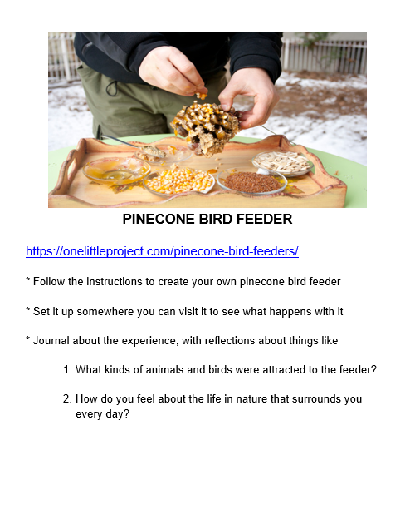

- Google and Other Sky Map Apps
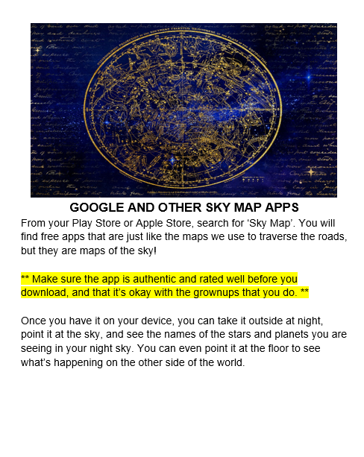

- Creative ways to Save the Planet
