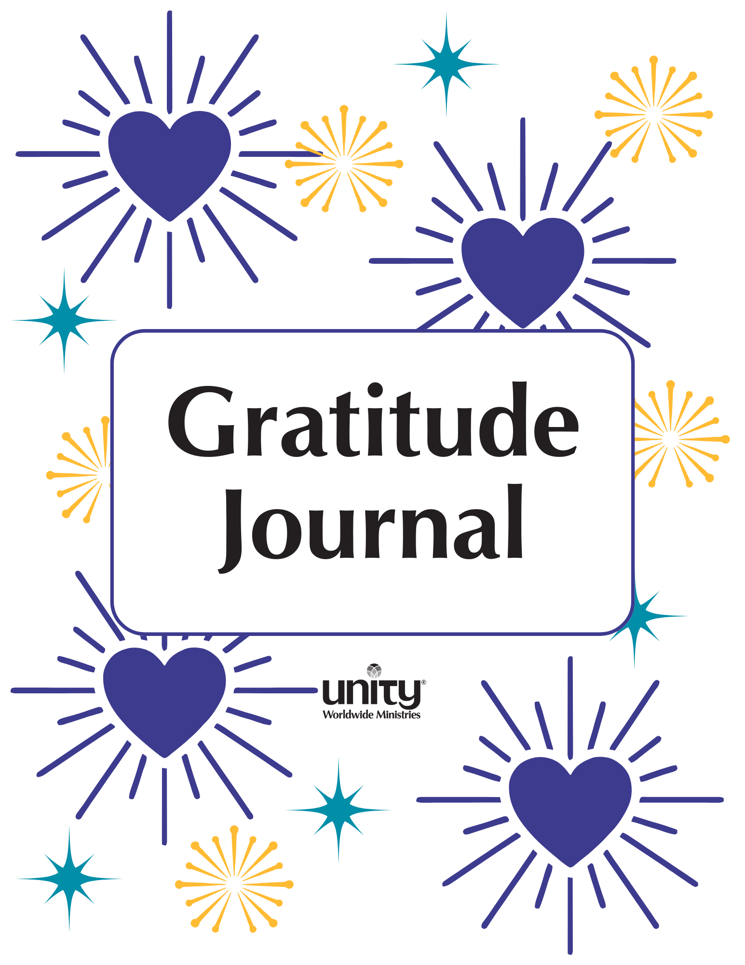
Introduction
“Gratitude is the law of increase. Whatever you bless with your thanks grows and multiplies.” – Myrtle Fillmore

Welcome to the Unity Worldwide Ministries 90-Day Gratitude Challenge!
Gratitude is more than just appreciation - it is a transformative spiritual practice. We are blessed when we give thanks not only for blessings already seen, but also for the good that is continually unfolding. Gratitude is not only a response to blessings received- is a spiritual law that calls forth abundance, health, love, and joy.
Each moment of conscious gratitude aligns our minds and hearts with the Divine flow, awakens a sense of abundance, and invites more love, peace, and prosperity into our lives.
Working with this journal each day, you’ll pause, reflect, and write a few lines. This practice will shift your awareness, uplift your spirit, and awaken new joy.

How to Use This Journal:
Begin each day by softly speaking the affirmation aloud, letting its words drift into your heart like morning light.
Pause to breathe and rest with the day’s gratitude prompt, allowing memories, sensations, and quiet joys to rise.
As inspiration arises, begin to share your thoughts in the space provided, however simple or lofty!
Finally, close your eyes and whisper a silent thank you, letting the feeling of gratitude fill your heart, ripple outward, and carry you through the day.

I give thanks for the infinite good now present.
With each breath, I welcome Divine abundance flowing through and around me.
May this practice open my heart to greater love, deeper peace, and joyful prosperity.
And so it is. Amen.
Table of Contents
Weekly Themes (ctrl+click for links)

Week 1: Gratitude for Abundance
Week 2: Gratitude for Health & Vitality.
Week 3: Gratitude for Loving Relationships
Week 4: Gratitude for Success & Purpose
Week 5: Gratitude for Inner Peace
Week 6: Gratitude for Joy & Celebration
Week 7: Gratitude for Nature & the Earth
Week 8: Gratitude for Creativity & Inspiration
Week 9: Gratitude for Spiritual Growth
Week 10: Gratitude for Community & Service
Week 11: Gratitude for Wisdom & Understanding
Week 12: Gratitude for Prosperity & Supply
Week 13: Gratitude for Life’s Ongoing Journey
What’s Next?
Week 1 – Gratitude for Abundance
(October 1-7)
Quote: “It is the law of Spirit that what you hold in mind manifests in your life. Gratitude keeps your mind stayed on good and draws more of it to you.” – Unity co-founder, Charles Fillmore

Day 1
Affirmation: I give thanks for the infinite abundance of Spirit that flows through me.
Invitation to Reflect: Tune into a recent time when you felt supported by life’s abundance. How did you recognize it? How did that experience feel? How did it change you?

Click or tap here to enter text.

Day 2
Affirmation: Divine substance is everywhere present, and I am richly supplied.
Gratitude Prompt: Think of one area of your life where you’d like to notice more supply. What can you be grateful for today in that area?

Click or tap here to enter text.

Day 3
Affirmation: I am open to the unlimited good of God.
Gratitude Prompt: Write about a time when something good came to you unexpectedly. How did it feel?

Click or tap here to enter text.

Day 4
Affirmation: Gratitude opens the door to greater blessings.
Gratitude Prompt: What is one blessing in disguise that you can now see clearly?

Click or tap here to enter text.

Day 5
Affirmation: I see prosperity as the natural state of my being.
Gratitude Prompt: What does prosperity mean to you, beyond money? What in your life already reflects this prosperity?

Click or tap here to enter text.

Day 6
Affirmation: I rejoice in the richness of life and the gifts of Spirit.
Gratitude Prompt: Notice three simple joys today that reflect richness in your life. Write them down with gratitude.

Click or tap here to enter text.

Day 7
Affirmation: I give thanks that I live, move, and have my being in abundance.
Gratitude Prompt: Reflect on the week. Where did you notice God’s abundance flowing through you?

Click or tap here to enter text.

Week 2 – Gratitude for Health & Vitality (October 8-14)
Quote: “Health is the consciousness of wholeness and harmony. Give thanks and live in that awareness.” – Myrtle Fillmore

Day 1
Affirmation: Every cell in my body radiates divine health.
Gratitude Prompt: Write about one way your body supported you today.

Click or tap here to enter text.

Day 2
Affirmation: I am grateful for the energy of life flowing through me.
Gratitude Prompt: Name three things that help you feel vibrant and alive.

Click or tap here to enter text.

Day 3
Affirmation: Perfect life renews me now.
Gratitude Prompt: Recall a time when your body surprised you with its strength or resilience.

Click or tap here to enter text.

Day 4
Affirmation: I listen to my body with love and compassion.
Gratitude Prompt: Describe how you honored your body’s needs today.

Click or tap here to enter text.

Day 5
Affirmation: I bless my body as a temple of the living Spirit.
Gratitude Prompt: What is one physical sensation you appreciate right now?

Click or tap here to enter text.

Day 6
Affirmation: Life flows easily and joyfully through me.
Gratitude Prompt: What movement or stillness felt especially nourishing today?

Click or tap here to enter text.

Day 7
Affirmation: I give thanks for my radiant health and vitality.
Gratitude Prompt: Reflect on your week. Where did you feel the presence of wholeness and well-being?

Click or tap here to enter text.

Week 3 – Gratitude for Loving Relationships (October 14-21)

Quote: “Love is the great harmonizer. In love we find the key to perfect relationships and abiding peace.” – Charles Fillmore

Day 1
Affirmation: I radiate love and attract loving relationships.
Gratitude Prompt: Who in your life has shown you kindness recently? How does it feel to allow your heart to fill with warm appreciation as you bring these individuals to mind?

Click or tap here to enter text.

Day 2
Affirmation: I give thanks for the friends who enrich my spirit.
Gratitude Prompt: Recall a moment when a friend or loved one made you feel truly seen.

Click or tap here to enter text.

Day 3
Affirmation: Divine love flows through every interaction I have today.
Gratitude Prompt: How did love show up for you today, even in a small way?

Click or tap here to enter text.

Day 4
Affirmation: I am thankful for the lessons every relationship brings.
Gratitude Prompt: What relationship has taught you the most about yourself?

Click or tap here to enter text.

Day 5
Affirmation: I bless all people with thoughts of peace and compassion.
Gratitude Prompt: Name someone you want to silently bless with gratitude today.

Click or tap here to enter text.

Day 6
Affirmation: Love is the essence of my being.
Gratitude Prompt: Describe a time you felt surrounded by unconditional love.

Click or tap here to enter text.

Day 7
Affirmation: I give thanks for the harmony and joy in my relationships.
Gratitude Prompt: Reflect on this week: where did you feel the presence of love?

Click or tap here to enter text.

Week 4 – Gratitude for Success & Purpose (October 22-28)
Quote: “Prosperity is not just having things; it is the consciousness of abundance and the assurance that all needs are met.” – Eric Butterworth

Day 1
Affirmation: I give thanks for my unique gifts and talents.
Gratitude Prompt: What ability or skill are you most grateful for today?

Click or tap here to enter text.

Day 2
Affirmation: Divine ideas guide me to inspired action.
Gratitude Prompt: Write about an idea that recently excited or motivated you.

Click or tap here to enter text.

Day 3
Affirmation: I celebrate every step toward my goals.
Gratitude Prompt: What progress, big or small, did you make this week?

Click or tap here to enter text.

Day 4
Affirmation: I am grateful for opportunities to serve and succeed.
Gratitude Prompt: Recall a moment when your work or service blessed others.

Click or tap here to enter text.

Day 5
Affirmation: I prosper as I follow my divine purpose.
Gratitude Prompt: What meaningful work or project lights you up right now?

Click or tap here to enter text.

Day 6
Affirmation: Abundance flows to me and through me.
Gratitude Prompt: Describe a recent experience of unexpected support or resources.

Click or tap here to enter text.

Day 7
Affirmation: I give thanks for success already unfolding.
Gratitude Prompt: Reflect on the week: how did you feel Spirit supporting your purpose?

Click or tap here to enter text.

Week 5 - Gratitude for Inner Peace (October 29-November 4)

Quote: “Peace is the reward of conscious oneness with God.” – Charles Fillmore

Day 1
Affirmation: I am centered in the peace of Spirit.
Gratitude Prompt: Describe a quiet moment this week when you felt deep inner calm.

Click or tap here to enter text.

Day 2
Affirmation: Divine peace flows through every part of my life.
Gratitude Prompt: What daily habit or practice helps you return to peace?

Click or tap here to enter text.

Day 3
Affirmation: I release worry and welcome serenity.
Gratitude Prompt: Recall a time you let go of a concern and discovered unexpected ease.

Click or tap here to enter text.

Day 4
Affirmation: I give thanks for the stillness within me.
Gratitude Prompt: Where do you feel peace most strongly in your body today?

Click or tap here to enter text.

Day 5
Affirmation: I am a presence of calm for others.
Gratitude Prompt: Who or what brought a sense of harmony to your day?

Click or tap here to enter text.

Day 6
Affirmation: Peace is my natural state.
Gratitude Prompt: How did you notice the Divine working through quiet moments this week?

Click or tap here to enter text.

Day 7
Affirmation: I dwell in the peace that passes understanding.
Gratitude Prompt: Reflect on the week: how has peace shown up for you?

Click or tap here to enter text.

Week 6 - Gratitude for Joy & Celebration (November 5-11)

Quote: “Joy is the evidence of God’s presence.” – Eric Butterworth

Day 1
Affirmation: I delight in the simple joys of life.
Gratitude Prompt: Name three small things that made you smile today.

Click or tap here to enter text.

Day 2
Affirmation: I celebrate each moment with a grateful heart.
Gratitude Prompt: Recall a recent celebration—big or small—that lifted your spirit.

Click or tap here to enter text.

Day 3
Affirmation: Divine joy overflows in me and through me.
Gratitude Prompt: Describe a memory that instantly brings you happiness.

Click or tap here to enter text.

Day 4
Affirmation: I give thanks for laughter and lightness.
Gratitude Prompt: What made you laugh recently, and how did it feel?

Click or tap here to enter text.

Day 5
Affirmation: I radiate joy and uplift those around me.
Gratitude Prompt: How did your joy brighten someone else’s day this week?

Click or tap here to enter text.

Day 6
Affirmation: My life is a celebration of Spirit.
Gratitude Prompt: Write about a personal achievement—large or small—you’re grateful for.

Click or tap here to enter text.

Day 7
Affirmation: I rejoice in the goodness of life.
Gratitude Prompt: Reflect on the week: where did you feel pure joy?

Click or tap here to enter text.

Week 7 – Gratitude for Nature & the Earth
(November 12-18)

Quote: “All of nature is the outpouring of divine life and substance. In its beauty and order we behold the face of God.” – Charles Fillmore

Day 1
Affirmation: I give thanks for the life force present in all creation.
Gratitude Prompt: Describe a moment in nature that recently inspired awe.

Click or tap here to enter text.

Day 2
Affirmation: I am one with the rhythms of the earth.
Gratitude Prompt: What natural sound, scent, or sight brings you peace?

Click or tap here to enter text.

Day 3
Affirmation: The beauty of creation nourishes my soul.
Gratitude Prompt: Write about a favorite place outdoors and why it feels sacred.

Click or tap here to enter text.

Day 4
Affirmation: I honor the earth and all living things.
Gratitude Prompt: How did you care for or appreciate the planet today?

Click or tap here to enter text.

Day 5
Affirmation: I delight in the wonder of the natural world.
Gratitude Prompt: Recall a time you felt deeply connected to the environment.

Click or tap here to enter text.

Day 6
Affirmation: Nature reflects the abundance of Spirit.
Gratitude Prompt: List three simple natural gifts you enjoyed today.

Click or tap here to enter text.

Day 7
Affirmation: I am grateful for the sustaining power of Mother Earth.
Gratitude Prompt: Reflect on how nature supported or blessed you this week.

Click or tap here to enter text.

Week 8 – Gratitude for Creativity & Inspiration
(November 19-25)
Quote: “Divine ideas are the substance of all things. To think is to create.” – Charles Fillmore

Day 1
Affirmation: I am a channel of divine creativity.
Gratitude Prompt: What creative activity or idea excites you today?

Click or tap here to enter text.

Day 2
Affirmation: Inspiration flows freely through me.
Gratitude Prompt: Recall a time when a sudden insight or idea surprised you.

Click or tap here to enter text.

Day 3
Affirmation: I give thanks for the spark of imagination within.
Gratitude Prompt: What is one way you expressed creativity this week?

Click or tap here to enter text.

Day 4
Affirmation: I am grateful for the art and beauty others share.
Gratitude Prompt: Describe a piece of art, music, or writing that moved you recently.

Click or tap here to enter text.

Day 5
Affirmation: Divine ideas guide my every endeavor.
Gratitude Prompt: How has an inspired thought helped you solve a challenge?

Click or tap here to enter text.

Day 6
Affirmation: I celebrate the creative Spirit alive in me.
Gratitude Prompt: List three things you created or improved today, no matter how small.

Click or tap here to enter text.

Day 7
Affirmation: I give thanks for infinite inspiration.
Gratitude Prompt: Reflect on how creativity showed up for you this week.

Click or tap here to enter text.

Week 9 – Gratitude for Spiritual Growth (November 19-25)

Quote: “As we turn our thoughts God-ward, the soul unfolds and the divine pattern is revealed.” – Charles Fillmore

Day 1
Affirmation: I give thanks for my ever-deepening spiritual awareness.
Gratitude Prompt: Recall a recent insight or realization that brought you closer to Spirit.

Click or tap here to enter text.

Day 2
Affirmation: My soul expands in wisdom and love.
Gratitude Prompt: Write about a practice—prayer, meditation, study—that has nourished your growth.

Click or tap here to enter text.

Day 3
Affirmation: I welcome divine guidance in every area of life.
Gratitude Prompt: When have you recently sensed inner guidance or intuition?

Click or tap here to enter text.

Day 4
Affirmation: I am grateful for the teachers and mentors Spirit provides.
Gratitude Prompt: Who has inspired your spiritual path this week?

Click or tap here to enter text.

Day 5
Affirmation: My consciousness is lifted by gratitude.
Gratitude Prompt: Describe a moment when you felt truly connected to the Divine.

Click or tap here to enter text.

Day 6
Affirmation: I rejoice in the unfolding of my spiritual gifts.
Gratitude Prompt: What unique spiritual talent or quality are you thankful for today?

Click or tap here to enter text.

Day 7
Affirmation: I am one with the Infinite.
Gratitude Prompt: Reflect on the week: where did you feel God’s presence most vividly?
Click or tap here to enter text.

Week 10 – Gratitude for Community & Service
(December 3-9)
Quote: “When we serve with love, we become channels of divine blessing for the whole world.” – Eric Butterworth

Day 1
Affirmation: I am grateful for the community that supports and uplifts me.
Gratitude Prompt: Who in your community made a difference in your life recently?

Click or tap here to enter text.

Day 2
Affirmation: I give thanks for opportunities to serve others.
Gratitude Prompt: Describe a simple act of service you offered or received this week.

Click or tap here to enter text.

Day 3
Affirmation: Love flows through me to bless the world.
Gratitude Prompt: How did you share kindness today?

Click or tap here to enter text.

Day 4
Affirmation: I am one with all people in Spirit.
Gratitude Prompt: Recall a time you felt a deep sense of belonging.

Click or tap here to enter text.

Day 5
Affirmation: I celebrate the diverse gifts of those around me.
Gratitude Prompt: Who in your community inspires you and why?

Click or tap here to enter text.

Day 6
Affirmation: I gratefully give and receive support.
Gratitude Prompt: Reflect on a moment of mutual help or collaboration this week.

Click or tap here to enter text.

Day 7
Affirmation: I bless my community and all beings with peace and abundance.
Gratitude Prompt: How will you continue to nurture your community in the days ahead?

Click or tap here to enter text.
Week 11 – Gratitude for Wisdom & Understanding (December 10-17)

Quote: “Divine wisdom is the voice of God within, guiding every thought and action.” – Charles Fillmore

Day 1
Affirmation: I give thanks for the wisdom of the Christ mind within me.
Gratitude Prompt: Recall a decision you made recently that felt divinely guided.

Click or tap here to enter text.

Day 2
Affirmation: Understanding grows as I listen in stillness.
Gratitude Prompt: When did quiet reflection bring you clarity this week?

Click or tap here to enter text.

Day 3
Affirmation: I trust the inner voice of Spirit.
Gratitude Prompt: Describe a time when intuition helped you.

Click or tap here to enter text.

Day 4
Affirmation: I am grateful for the lessons of life.
Gratitude Prompt: What challenge has offered unexpected understanding?

Click or tap here to enter text.

Day 5
Affirmation: Divine intelligence works through me.
Gratitude Prompt: Name a person or resource that shared helpful insight recently.

Click or tap here to enter text.

Day 6
Affirmation: I celebrate the unfolding of my spiritual understanding.
Gratitude Prompt: How has your perspective shifted for the better this week?

Click or tap here to enter text.

Day 7
Affirmation: I live in harmony with divine wisdom.
Gratitude Prompt: Reflect on a situation where understanding brought peace.
.
Click or tap here to enter text.

Week 12 – Gratitude for Prosperity & Supply (December 18-24)

Quote: “Prosperity is the consciousness of God’s abundance, freely available to all.” – Myrtle Fillmore

Day 1
Affirmation: I give thanks for the flow of abundance in my life.
Gratitude Prompt: What unexpected gift or resource blessed you this week?
Click or tap here to enter text.

Day 2
Affirmation: Divine substance meets every need.
Gratitude Prompt: Describe a recent experience of having “enough” or more than enough.
Click or tap here to enter text.

Day 3
Affirmation: I welcome opportunities to prosper and share.
Gratitude Prompt: How have you given or received generosity lately?
Click or tap here to enter text.

Day 4
Affirmation: Abundance is my natural state.
Gratitude Prompt: What area of your life already overflows with goodness?
Click or tap here to enter text.

Day 5
Affirmation: I prosper as I bless others.
Gratitude Prompt: Write about a way you supported someone else’s well-being.
Click or tap here to enter text.

Day 6
Affirmation: I rejoice in the richness of Spirit.
Gratitude Prompt: What simple pleasures feel luxurious to you?
Click or tap here to enter text.

Day 7
Affirmation: I am grateful for infinite supply and divine order.
Gratitude Prompt: Reflect on the week: where did you notice prosperity’s quiet presence?
Click or tap here to enter text.

Week 13 – Gratitude for Life’s Ongoing Journey (December 25-31)

Quote: “Life is consciousness; what you think and thank on grows. Gratitude lifts the mind into the awareness of eternal good.” – Myrtle Fillmore

Day 1
Affirmation: I give thanks for the gift of life and the adventure of each new day.
Gratitude Prompt: Recall a recent experience that reminded you how precious life is.
Click or tap here to enter text.

Day 2
Affirmation: I trust the divine flow guiding my path.
Gratitude Prompt: Write about a change or transition you’re grateful for right now.
Click or tap here to enter text.

Day 3
Affirmation: Each step I take is blessed and purposeful.
Gratitude Prompt: What lesson from this 90-day journey has meant the most to you?
Click or tap here to enter text.

Day 4
Affirmation: I give thanks for the mystery and wonder of the unknown.
Gratitude Prompt: How can you welcome uncertainty with gratitude?
Click or tap here to enter text.

Day 5
Affirmation: My life is a continuous expression of love and abundance.
Gratitude Prompt: Describe a moment when you felt completely alive and connected.
Click or tap here to enter text.

Day 6
Affirmation: I honor the past, bless the present, and welcome the future.
Gratitude Prompt: What past event do you now see as a blessing?
Click or tap here to enter text.

Day 7
Affirmation: I am open to everyday miracles, and I give thanks for the blessings seen and unseen in my life.
Gratitude Prompt: What small "ordinary" moments did I notice recently that carry a spark of the Divine? How does this change the way I see my day-to-day life?
Click or tap here to enter text.

Day 8
Affirmation: I carry the spirit of gratitude into every tomorrow.
Gratitude Prompt: How will you continue your gratitude practice beyond these 90 days?
Click or tap here to enter text.

What’s Next?
“Gratitude, appreciation, and thanksgiving are the three attitudes that ensure happiness and wholeness.” – Myrtle Fillmore

🌟 Closing Reflection
As you complete this 90-Day Unity Gratitude Challenge, pause to honor your dedication. Gratitude is more than a practice - it is a way of living!
May you carry this spirit into every tomorrow, noticing blessings in ordinary moments and letting your thankful heart be a magnet for joy, love, and abundance.

Challenge Forward
• Continue writing three gratitudes each day.
• Share your gratitude with others - speak it, write it, live it.
• Let gratitude guide you into inspired living, connected relationships, and deeper spiritual awareness.

Share any closing thoughts in the space below:
Click or tap here to enter text.

If this Gratitude Challenge or another program led by Unity Worldwide Ministries has touched your heart or inspired you in some way, please consider supporting our mission!

Our website is www.UnityUWM.org, or you may mail in a gift to 200 Unity Circle N. Ste. A, Lee's Summit Mo 64086.
Thank you for your support toward furthering our work in the world…
With you as our Partner, we are able to create even more ripple effects of good in the world!

